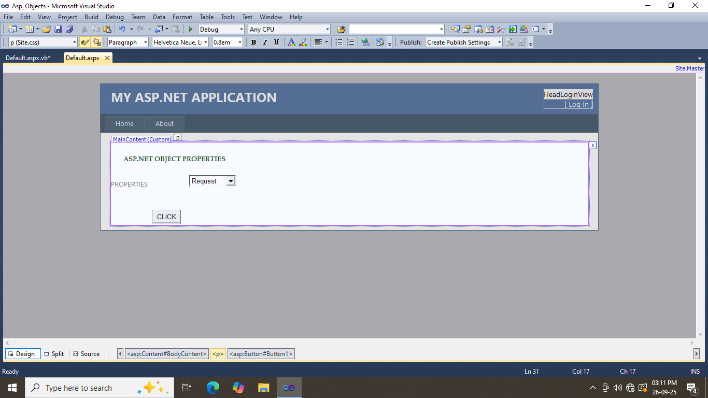

PublicClass_Default

InheritsSystem.Web.UI.Page

DimselectedobjectAsString

Dim properties AsString

ProtectedSub Button1_Click(ByVal sender AsObject, ByVal e AsEventArgs) Handles Button1.Click

selectedobject = DropDownList1.SelectedValue

properties = " "

SelectCaseselectedobject

Case"Request"

properties = DisplayRequestProperties()

Case"Response"

properties = DisplayResponseProperties()

Case"Session"

properties = DisplaySessionProperties()

Case"Application"

properties = DisplayApplicationProperties()

EndSelect

Label2.Text = properties

EndSub

PrivateFunctionDisplayRequestProperties() AsString

'properties += "Request URL:" + Request.Url + "<br/>"

properties += "Request Method:" + Request.HttpMethod + "<br/>"

properties += "request User Host address:" + Request.UserHostAddress + "<br/>"

Return properties

EndFunction

PrivateFunctionDisplayResponseProperties() AsString

properties += "Response Status Code:" + Str(Response.StatusCode) + "<br/>"

properties += "Response Status description:" + Response.StatusDescription + "<br/>"

Return properties

EndFunction

PrivateFunctionDisplaySessionProperties() AsString

properties += "Session ID:" + Session.SessionID + "<br/>"

properties += "Session Timeout:" + Str(Session.Timeout) + "<br/>"

Return properties

EndFunction

PrivateFunctionDisplayApplicationProperties() AsString

properties += "Application Path:" + Request.ApplicationPath + "<br/>"

Return properties

EndFunction

EndClass

